无刷直流行星齿轮减速电机（内齿圈材质:金属和粉末金属）
BLDC Planetary Gear Motor （Ring Gear Material: Metal and Powder Metal）
Φ36 行星减速器,允许转矩范围:0.3N.m~3.0N.m
36JXE30K/36ZWN42 36mm OD Planetary Gearbox,
Permissible Load Range: 0.3N.m~3.0N.m

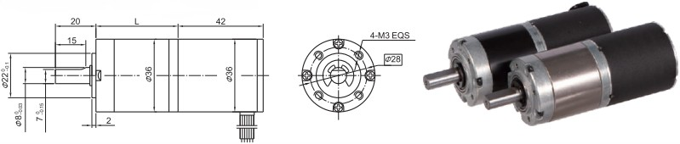
  - 外形和安装尺寸 Dimensions

  - 无刷电动机主要技术参数 Brushless Motor Technical Data
电机型号  TYPE | 极数Number of poles | 相数Number of phase | 额定电压Rated Voltage VDC | 空载转速No-load Speed r/min | 额定转速Rated Speed r/min | 额定转矩Rated Torque mN.m | 额定功率Rated Power  W | 峰值转矩Reak Torque  mN.m
36ZWN42-2430 | 8 | 3 | 24 | 3000 | 2100 | 32 | 7 | 160
36ZWN42-2440 | 8 | 3 | 24 | 4000 | 2800 | 36 | 10 | 180
  - 无刷行星齿轮减速电机主要技术参数 Brushless Gear Motor Technical Data
配置 36ZWN42-2430 无刷直流电机(36ZWN42-2430 BLDC Motor)
减速比 Reduction ratio | 3.7 | 5.2 | 14 | 19 | 27 | 51 | 71 | 100 | 139 | 189 | 264
减速级数 Number of gear trains | 1 | 1 | 2 | 2 | 2 | 3 | 3 | 3 | 3 | 4 | 4
减速器长度(L) Lengh(L) mm | 26.5 | 26.5 | 33.6 | 33.6 | 33.6 | 40.5 | 40.5 | 40.5 | 40.5 | 47.4 | 47.4
空载转速 No-lod speed r/min | 809 | 576 | 214 | 158 | 111 | 59 | 42 | 30 | 22 | 16 | 11
额定转速 Rated speed r/min | 566 | 405 | 150 | 111 | 78 | 41 | 30 | 23 | 18 | 13 | 8.0
额定转矩 Rated torque N.m | 0.09 | 0.13 | 0.31 | 0.42 | 0.59 | 1.0 | 1.4 | 2.0 | 2.5 | 3 | 3
最大瞬间允许负载 N.m Max. permissible load in a short time | 1.0 | 1.0 | 3.5 | 3.5 | 3.5 | 7.5 | 7.5 | 7.5 | 7.5 | 9 | 9

配置 36ZWN42-2440 无刷直流电机(36ZWN42-2440 BLDC Motor)

减速比 Reduction ratio | 3.7 | 5.2 | 14 | 19 | 27 | 51 | 71 | 100 | 139 | 189 | 264
减速级数 Number of gear trains | 1 | 1 | 2 | 2 | 2 | 3 | 3 | 3 | 3 | 4 | 4
减速器长度(L) Lengh(L) mm | 26.5 | 26.5 | 33.6 | 33.6 | 33.6 | 40.5 | 40.5 | 40.5 | 40.5 | 47.4 | 47.4
空载转速 No-lod speed r/min | 1078 | 772 | 286 | 211 | 148 | 78 | 56 | 40 | 29 | 21 | 15
额定转速 Rated speed r/min | 755 | 541 | 200 | 147 | 104 | 55 | 39 | 30 | 23 | 18 | 14
额定转矩 Rated torque N.m | 0.10 | 0.14 | 0.34 | 0.46 | 0.66 | 1.1 | 1.6 | 2.2 | 2.5 | 3 | 3
最大瞬间允许负载 N.m Max. permissible load in a short time | 1.0 | 1.0 | 3.5 | 3.5 | 3.5 | 7.5 | 7.5 | 7.5 | 7.5 | 9 | 9

- 接线方式 Wire Diagram

U | V | W | Vcc | Ha | Hb | He | GND
红  Red | 棕  Brown | 黑  Black | 蓝  Blue | 黄  Yellow | 棕  Brown | 红  Red | 绿  Green
22AWG UL1007 |  |  | 26AWG UL1007

