永磁直流行星齿轮电机（内齿圈材质:金属）
PM DC Planetary Gear Motor (Ring Gear Material: Powder Metal)
22JN10K/22ZY38
Φ22 行星减速器，允许转矩范围：0.1N.m~1.0N.m
22mm OD Planetary Gearbox,
Permissible Load Range:0.1N.m~1.0
N.m
减速器输出轴直径可以做成Φ6,轴伸长度20
The diameter of the gearbox output shaft can be madeΦ6, the shaft length can be made 20
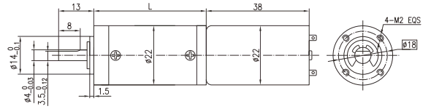
- 外形和安装尺寸Dimensions
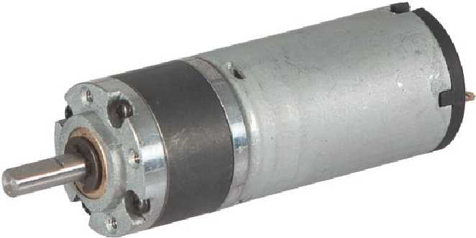

- 电动机主要技术参数Motor Technical Data
电机型号  Type | 额定电压  Rated  voltage  VDC | 空载转速  No-load  Speed  r/min | 空载电流  No-load  Current  mA | 额定转速  Rated  Speed  r/min | 额定转矩  Rated  Torque  mN.m | 输出功率  Output  power  W | 额定电流  Rated  current  mA | 堵转力矩  Stall  Torque  mN.m | 堵转电流  Stall  current  A
22ZY38B-1230 | 12 | 3000 | 70 | 2200 | 3 | 0.7 | 135 | 9.3 | 0.26
22ZY38B-1260 | 12 | 6000 | 100 | 5000 | 3 | 1.56 | 250 | 17 | 0.87

- 齿轮减速电机主要技术参数Gear Motor Technical Data
配置22ZY38B-1230直流电机(22ZY38B-1230 DC Motor)
减速比 Reduction ratio | 4 | 4.75 | 16 | 19 | 22 | 64 | 76 | 90 | 107 | 256 | 304
减速级数 Number of gear trains | 1 | 1 | 2 | 2 | 2 | 3 | 3 | 3 | 3 | 4 | 4
减速器长度(L) Length(L) mm | 13.0 | 13.0 | 16.7 | 16.7 | 16.7 | 20.4 | 20.4 | 20.4 | 20.4 | 24.1 | 24.1
空载转速 No-load speed r/min | 750 | 632 | 188 | 158 | 136 | 47 | 39 | 33 | 28 | 12 | 10
额定转速 Rated speed r/min | 550 | 463 | 138 | 116 | 100 | 34 | 29 | 24 | 21 | 8.6 | 7.2
额定转矩 Rated torque N.m | 0.011 | 0.013 | 0.039 | 0.046 | 0.053 | 0.14 | 0.17 | 0.20 | 0.23 | 0.3 | 0.3
最大瞬间允许负载 N.m  Max. permissible load in a short time | 0.09 | 0.09 | 0.45 | 0.45 | 0.45 | 0.75 | 0.75 | 0.75 | 0.75 | 0.9 | 0.9

配置22ZY38B-1260直流电机(22ZY38B-1260 DC Motor)
减速比 Reduction ratio | 4 | 4.75 | 16 | 19 | 22 | 64 | 76 | 90 | 107 | 256 | 304
减速级数 Number of gear trains | 1 | 1 | 2 | 2 | 2 | 3 | 3 | 3 | 3 | 4 | 4
减速器长度(L) Length(L) mm | 13.0 | 13.0 | 16.7 | 16.7 | 16.7 | 20.4 | 20.4 | 20.4 | 20.4 | 24.1 | 24.1
空载转速 No-load speed r/min | 1500 | 1263 | 375 | 316 | 273 | 94 | 79 | 67 | 56 | 23 | 20
额定转速 Rated speed r/min | 1250 | 1035 | 313 | 263 | 227 | 78 | 66 | 56 | 47 | 20 | 16
额定转矩 Rated torque N.m | 0.011 | 0.013 | 0.039 | 0.046 | 0.053 | 0.14 | 0.17 | 0.20 | 0.23 | 0.3 | 0.3
最大瞬间允许负载 N.m  Max. permissible load in a short time | 0.09 | 0.09 | 0.45 | 0.45 | 0.45 | 0.75 | 0.75 | 0.75 | 0.75 | 0.9 | 0.9

- 电动机特性图 Motor Characteristic Figure
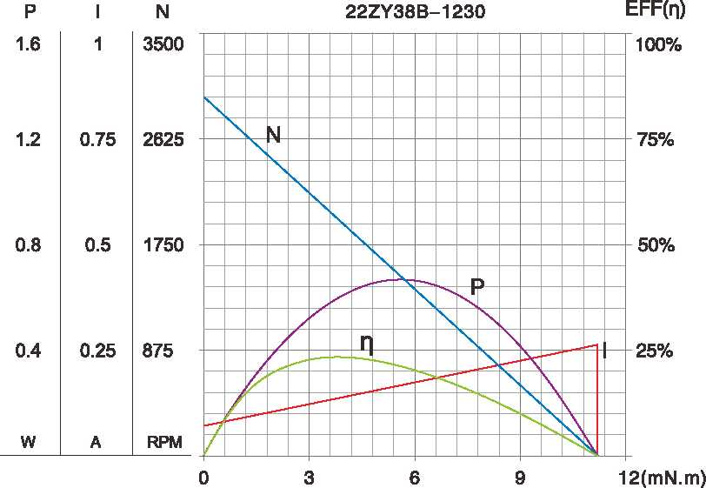
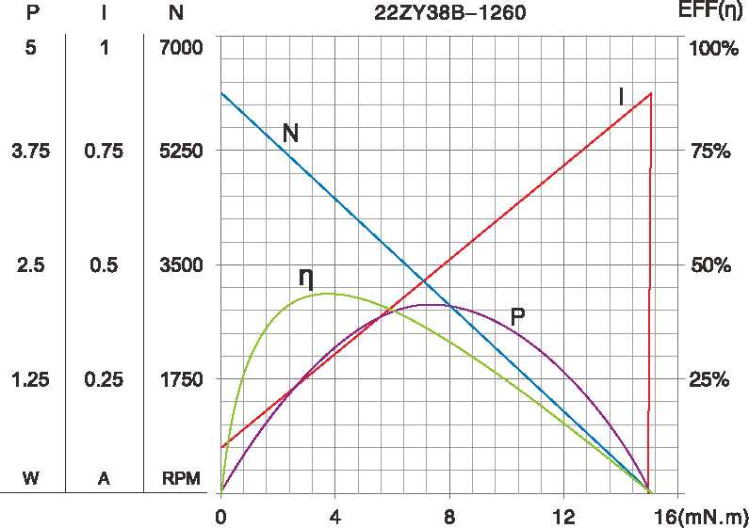

A-1

技术参数如有变动，如不另行通知

